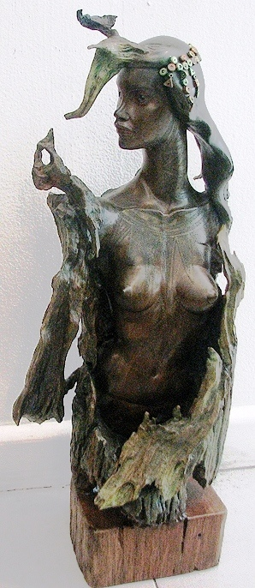

*Benjamin Dailo*

Driftwood sculpture, 2008.

Height 23” ; Depth 7” ; Width 10”

No title